1. Convert into 1NF (First Normal Form)
Given Table
Member_ Id | FirstName | LastName | Hobbies
101 | Jayson | Mark | Cricket, Swimming, Football
102 | Ram | Ganesh | Swimming, Running, Music
103 | Raj | Kishore | Dancing, Singing, Running

Problem
The Hobbies column contains multiple values
1NF Rule
Each cell must contain only one value.
Converted Table (1NF)
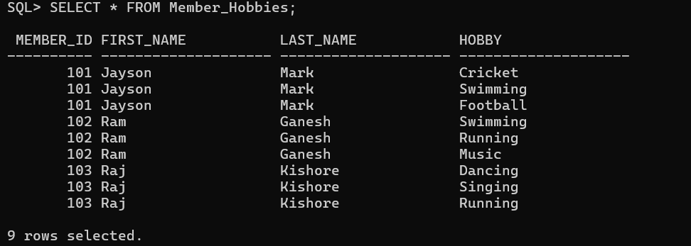
Queries
CREATE TABLE Member_Hobbies(
Member_Id NUMBER,
First_Name VARCHAR2(20),
Last_Name VARCHAR2(20),
Hobby VARCHAR2(20) );
Problem 2: Normalize the following table into 2nd Normal Form (2NF)
Given Table
Empno | Training | Training_Date | Dept
101 | Oracle SQL | 12-Aug-2015 | TT
101 | Java | 21-Aug-2015 | BU
102 | Oracle SQL | 18-Sep-2014 | TT

Query
Employee Table
CREATE TABLE Employee (
Empno INT PRIMARY KEY,
Dept VARCHAR(20)
);
INSERT INTO Employee VALUES
(101,'TT'),
(102,'TT');
SELECT * FROM Employee;
Training Table
CREATE TABLE Training (
Empno INT,
Training VARCHAR(30),
Training_Date DATE
);
INSERT INTO Training VALUES
(101,'Oracle SQL','12-AUG-2015'),
(101,'Java','21-AUG-2015'),
(102,'Oracle SQL','18-SEP-2014');
SELECT * FROM Training;

Output
Employee Table
Empno | Dept
101 | TT
102 | TT
Training Table
Empno | Training | Training_Date
101 | Oracle SQL | 12-Aug-2015
101 | Java | 21-Aug-2015
102 | Oracle SQL | 18-Sep-2014

Problem 3: Normalize the following table into 3rd Normal Form (3NF)
Given Table
Member_Id | First_Name | Last_Name | Sports | Fees
101 | Rajesh | Chand | Cricket | 100
102 | Jayesh | Raj | Hockey | 80
103 | Mark | Dorson | Football | 90

Query
Member Table
CREATE TABLE Member (
Member_Id INT PRIMARY KEY,
First_Name VARCHAR(30),
Last_Name VARCHAR(30),
Sports VARCHAR(30)
);
INSERT INTO Member VALUES
(101,'Rajesh','Chand','Cricket'),
(102,'Jayesh','Raj','Hockey'),
(103,'Mark','Dorson','Football');
SELECT * FROM Member;
Sports_Fees Table
CREATE TABLE Sports_Fees (
Sports VARCHAR(30) PRIMARY KEY,
Fees INT
);
INSERT INTO Sports_Fees VALUES
('Cricket',100),
('Hockey',80),
('Football',90);
SELECT * FROM Sports_Fees;

Output
Member Table
Member_Id | First_Name | Last_Name | Sports
101 | Rajesh | Chand | Cricket
102 | Jayesh | Raj | Hockey
103 | Mark | Dorson | Football
Sports_Fees Table
Sports | Fees
Cricket | 100
Hockey | 80
Football | 90

